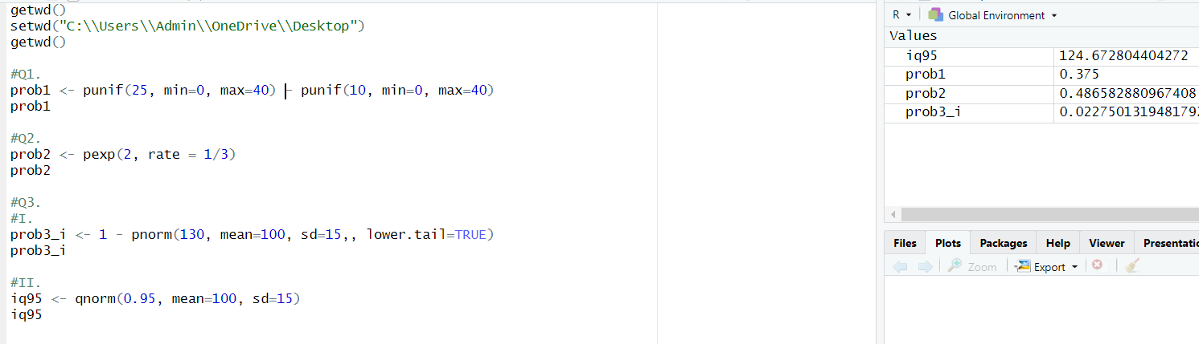**IT24100198 Pavinthan.V  
Lab07_PS**  
